**The Model**

Let’s build a complex machine learning model (a neural network) predicting the Sex (the probability of being a man, as women are here the reference level) of our participants with all the variables of the dataframe.

# Load packages

library(tidyverse)

library(caret)

library(psycho)

# Import data

df <- psycho::affective %>%

standardize() %>% # Standardize

na.omit(df) # Remove missing values

# Fit the model

model <- caret::train(Sex ~ .,

data=df,

method = "nnet")

varImp(model, scale = TRUE)

## nnet variable importance

##

## Overall

## Salary2000+ 100.000

## Concealing 48.761

## Adjusting 46.198

## Birth_SeasonSpring 39.289

## Life_Satisfaction 22.567

## Salary<2000 9.176

## Birth_SeasonSummer 8.863

## Birth_SeasonWinter 6.624

## Tolerating 5.686

## Age 0.000

It seems that the upper salary category (*> 2000€ / month*) is the most important variable of the model, followed by the concealing and adjusting personality traits. Interesting, but what does it say about the actual relationship between those variables and our outcome?

**Simple**

To visualize the effect of Salary, we can extract a reference data with all the salary levels and all other variables fixed at their mean level.

newdata <- df %>%

select(-Sex) %>% # We remove the sex as it is our variable "to predict"

refdata("Salary")

newdata

knitr::kable(newdata, digits=2)

| **Salary** | **Age** | **Birth_Season** | **Life_Satisfaction** | **Concealing** | **Adjusting** | **Tolerating** |
| --- | --- | --- | --- | --- | --- | --- |
| <1000 | 0.11 | Fall | -0.01 | 0 | 0.03 | -0.02 |
| <2000 | 0.11 | Fall | -0.01 | 0 | 0.03 | -0.02 |
| 2000+ | 0.11 | Fall | -0.01 | 0 | 0.03 | -0.02 |

We can make predictions from the model on this minimal dataset and visualize it.

predicted <- predict(model, newdata, type = "prob")

newdata <- cbind(newdata, predicted)

newdata %>%

ggplot(aes(x=Salary, y=M, group=1)) +

geom_line() +

theme_classic() +

ylab("Probability of being a man")

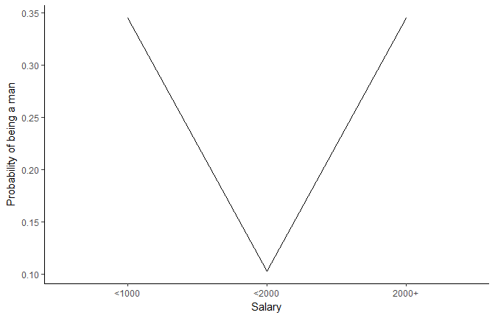

Well, it seems that males are more represented in categories with lower and uppper salary classes (that least, that’s what the model learnt).

**Multiple Targets**

How does this interact with the concealing personality trait?

newdata <- df %>%

select(-Sex) %>%

refdata(c("Salary", "Concealing")) # We can sepcify multiple targets

newdata

knitr::kable(head(newdata, 5), digits=2)

| **Salary** | **Concealing** | **Age** | **Birth_Season** | **Life_Satisfaction** | **Adjusting** | **Tolerating** |
| --- | --- | --- | --- | --- | --- | --- |
| <1000 | -2.52 | 0.11 | Fall | -0.01 | 0.03 | -0.02 |
| <2000 | -2.52 | 0.11 | Fall | -0.01 | 0.03 | -0.02 |
| 2000+ | -2.52 | 0.11 | Fall | -0.01 | 0.03 | -0.02 |
| <1000 | -1.99 | 0.11 | Fall | -0.01 | 0.03 | -0.02 |
| <2000 | -1.99 | 0.11 | Fall | -0.01 | 0.03 | -0.02 |

This created 10 evenly spread values of Concealing (from min to max) and “merged” them with all the levels of Salary.

predicted <- predict(model, newdata, type = "prob")

newdata <- cbind(newdata, predicted)

newdata %>%

ggplot(aes(x=Concealing, y=M, colour=Salary)) +

geom_line() +

theme_classic() +

ylab("Probability of being a man")

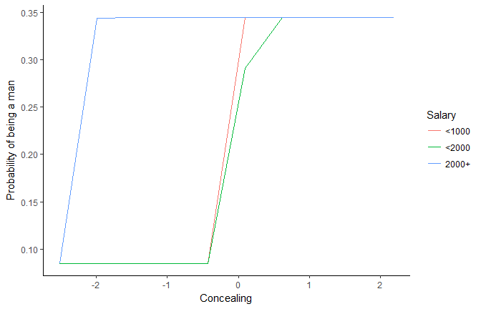

This plot is rather ugly…

**Increase Length**

newdata <- df %>%

select(-Sex) %>%

refdata(c("Salary", "Concealing"), length.out=500) # Set the length by which to spread numeric targets

predicted <- predict(model, newdata, type = "prob")

newdata <- cbind(newdata, predicted)

newdata %>%

ggplot(aes(x=Concealing, y=M, colour=Salary)) +

geom_line(size=1) +

theme_classic() +

ylab("Probability of being a man")

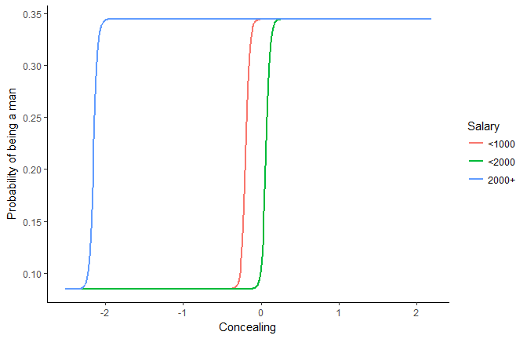

It seems that for richer people, the concealing treshold for increasing the probability of being a male is lower.

**How to Fix (Maintain) Numeric Variables?**

For now, all other variables were fixed to their mean level. But maybe their behaviour would be different when other variables are low or high.

newdata_min <- df %>%

select(-Sex) %>%

refdata(c("Salary", "Concealing"), length.out=500, numerics = "min") %>% # Set the other numeric variables to their minimum

mutate(Fixed = "Minimum")

newdata_max <- df %>%

select(-Sex) %>%

refdata(c("Salary", "Concealing"), length.out=500, numerics = "max")%>% # Set the other numeric variables to their maximum

mutate(Fixed = "Maximum")

newdata <- rbind(newdata_min, newdata_max)

predicted <- predict(model, newdata, type = "prob")

newdata <- cbind(newdata, predicted)

newdata %>%

ggplot(aes(x=Concealing, y=M, colour=Salary)) +

geom_line(size=1) +

theme_classic() +

ylab("Probability of being a man") +

facet_wrap(~Fixed)

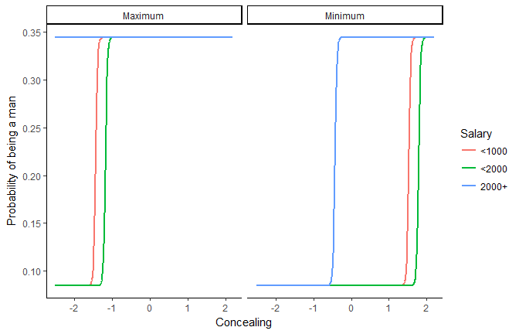

When all variables are high, concealing is not related to the sex for richer people. When the variables are set to their minimum, the concealing treshold for the two lower salary classes is higher (around 1.5).

**Chains of refdata**

Let’s say we want one target of length 500 and another to length 10 To do it, we can nicely chain refdata.

newdata <- df %>%

select(-Sex) %>%

refdata(c("Adjusting", "Concealing"), length.out=500) %>%

refdata("Adjusting", length.out=10, numerics = "combination")

predicted <- predict(model, newdata, type = "prob")

newdata <- cbind(newdata, predicted)

newdata %>%

mutate(Adjusting=as.factor(round(Adjusting, 2))) %>%

ggplot(aes(x=Concealing, y=M, alpha=Adjusting)) +

geom_line(size=1) +

theme_classic() +

ylab("Probability of being a man")

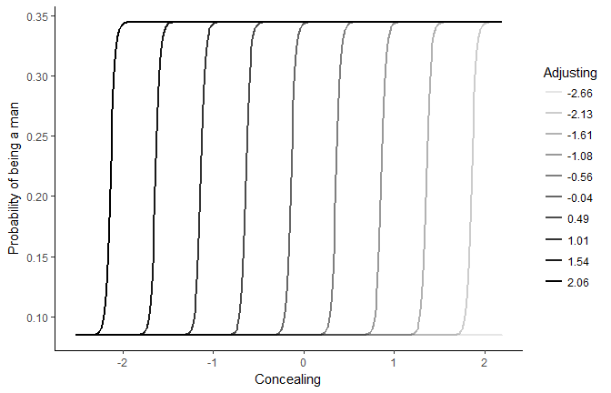

The concealing treshold highly depends on adjusting. The more adjusting is high (dark lines), the less concealing is needed to increase the probability of being a man.

**Combinations of Observed Values**

Let’s observe the link with Adjusting by generating a reference grid with all combinations of factors (salary, birth month etc.), and fixing numerics to their median (we could also chose “combinations” but it would generate a very, very very big dataframe with all possible combinations of values).

newdata <- df %>%

select(-Sex) %>%

refdata("Adjusting", length.out=10, factors = "combination", numerics = "median")

predicted <- predict(model, newdata, type = "prob")

newdata <- cbind(newdata, predicted)

newdata %>%

ggplot(aes(x=Adjusting, y=M)) +

geom_jitter(size=1, width=0, height = 0.01) +

geom_smooth(size=1, se=FALSE) +

theme_classic() +

ylab("Probability of being a man")

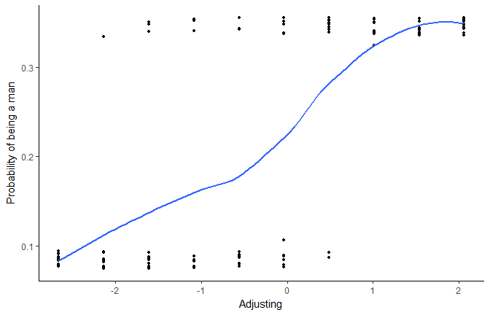

The more adjusting is high, the more probability there is to be a man. **But let’s generate now much more observations**.

newdata <- df %>%

select(-Sex) %>%

refdata("Adjusting", length.out=10000, factors = "combination", numerics = "median")

predicted <- predict(model, newdata, type = "prob")

newdata <- cbind(newdata, predicted)

newdata %>%

ggplot(aes(x=Adjusting, y=M)) +

geom_jitter(size=1, width=0, height = 0.01, alpha=0.2) +

geom_smooth(size=1, se=FALSE) +

theme_classic() +

ylab("Probability of being a man")

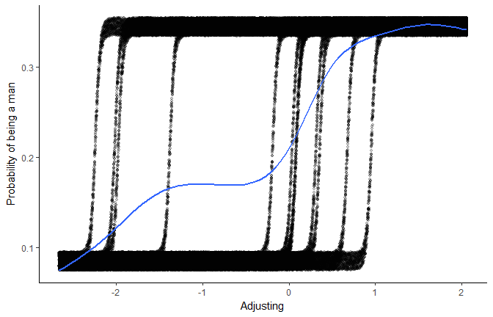

We can still see, “behind the scenes”, how different factors influence this relationship.

**Credits**

This package helped you? Don’t forget to cite the various packages you used :)